National Student Engagement Network

29th November 2023

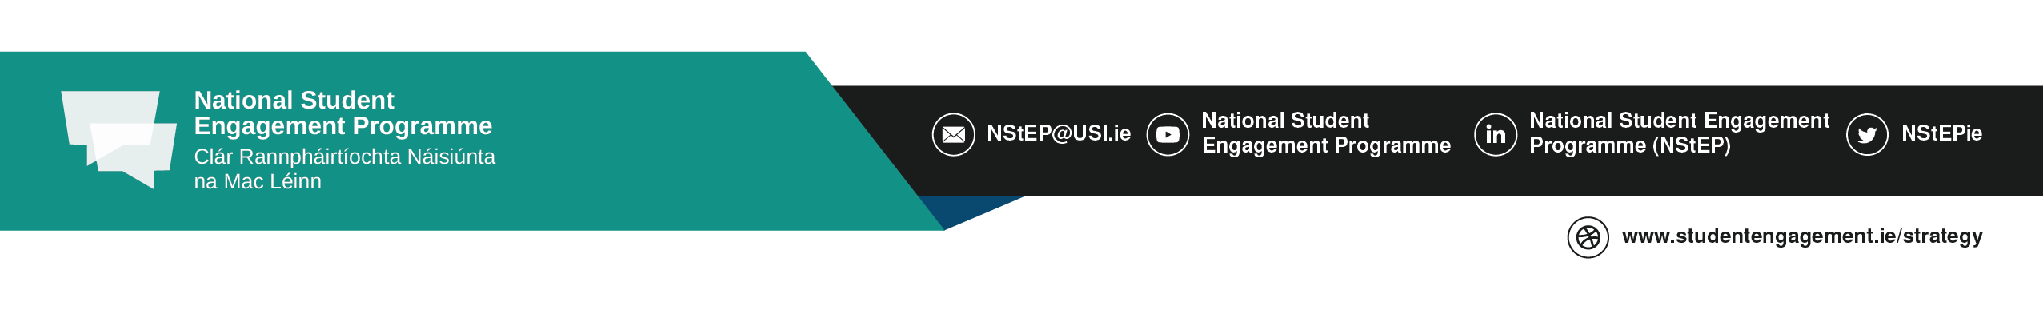
RCSI University of Medicine and Health Sciences
Time | Session
10.00 am – 10.30 am | Registration (Tea & Coffee)
10.30 am – 11.00 am | Welcome
11.00 am – 11.15 am | NStEP Student Engagement, Wellbeing and Belonging Project Update
11.15 am – 12.00 pm | Keynote: Creating a Sense of Belonging through the Student Learning Experience  Megan Brown, sparqs
12.00 pm – 1.00 pm | Project Highlights: Student Engagement in Wellbeing Initiatives  - Yvonne Kennedy, Wellbeing Officer/Healthy Campus Coordinator, ATU Sligo  - Jennifer Donnelly, PhD Scholar, RCSI University of Medicine and Health Sciences  - Professor Celine J.Marmion, Deputy Dean for Student Engagement, RCSI University of Medicine and Health Sciences  - Nadim Sayani & Mark Polemidiotis, Graduate Entry Medicine Students, RCSI University of Medicine and Health Sciences
1.00 pm – 2.00 pm | Lunch
Breakout Sessions
2 pm – 2.50 pm | Staff Session: Student Engagement, Wellbeing and Belonging Consultation | Student Rep/Student Union Session: Student Engagement, Wellbeing and Belonging Consultation
2.50 pm – 3.00 pm | Feedback Session
Close

