National Student Engagement Network

9th May 2023

Dublin City University, U-Building

Time | Session
10.00 am – 10.30 am | Registration (Tea & Coffee)
10.30 am – 11.00 am | Welcome and NStEP Update
11.00 am – 1.00 pm | NStEP Case Study Hub Highlight  - Rob Lowney, DCU – Student Partnership in Assessment  - Lesley Cotter, MTU – TIPToP Conference  - Yvonne Kavanagh, SETU Carlow – P2P Support – Students Helping Students  - Lindsay Dowling, Technological University Dublin – Diversifying the Curriculum, Building MultiStories
1.00 pm – 1.40 pm | Lunch
Parallel Sessions
1.40 pm – 2.30 pm | Staff Session: Student Engagement, Wellbeing and Belonging Brainstorm | Student Rep/Student Union Session: Student Governance Module Brainstorm
2.30 pm – 3.00 pm | Student Engagement Recognition Awards (SERA)
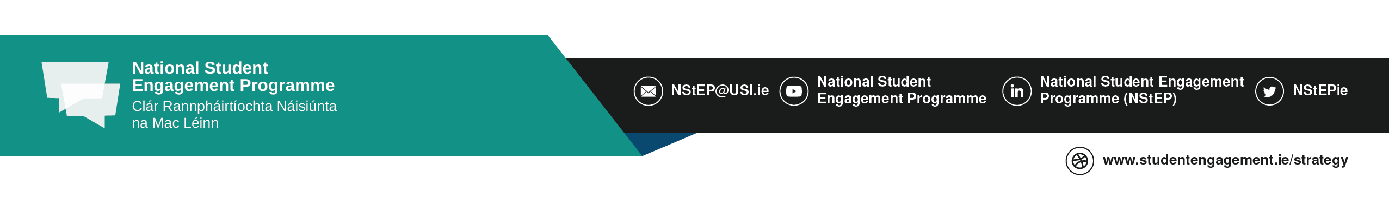
Close

