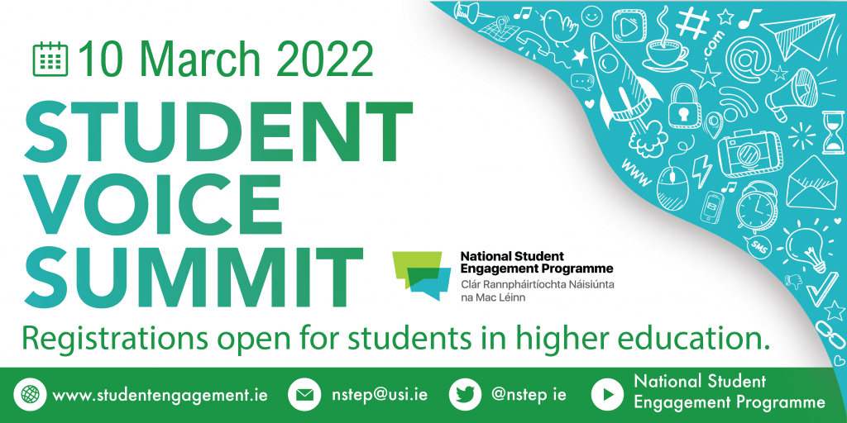
Participant Reflection
Answer the following reflection questions to receive a ‘Student Engagement Event’ milestone award. This award comes in the form of a digital badge, which are verified and portable online, allowing you to share them across web platforms (such as LinkedIn) to demonstrate your achievements and the skills they have developed. This milestone can be used when working towards a Student Engagement Recognition Award. More information on how to achieve this award can be found at https://studentengagement.ie/awards/
Follow these instructions to ensure your reflection is successfully submitted:
- Type your name, email address, and college into the corresponding spaces below.
- Answer the two questions in this word document. There is no word count limit, but we imagine that it may take approximately 300 words to develop your answers.
- Email this form as an attachment to nstepdevelopment@usi.ie by 5:00pm on Friday, 18 March 2022.
- If your reflection form has met all the requirements for the milestone award, this will be released to the email address provided on this form by 31 March 2022.

Please note: All information you provide on this reflection form will only be used to issue your award. If NStEP would like to use your response to support its work, we will contact you to ask permission first, and your responses will be anonymously by NStEP.

Personal Information:
Name:

Email Address:

College:

Reflection Questions:
- Reflecting on Maisha Islam and Cameron Keighron’s keynote presentations, what are two things that you learned today that you did not know before?

- Describe two things that you think could be done to help create inclusive student-staff partnerships in your college?

